**BASE MODEL**  
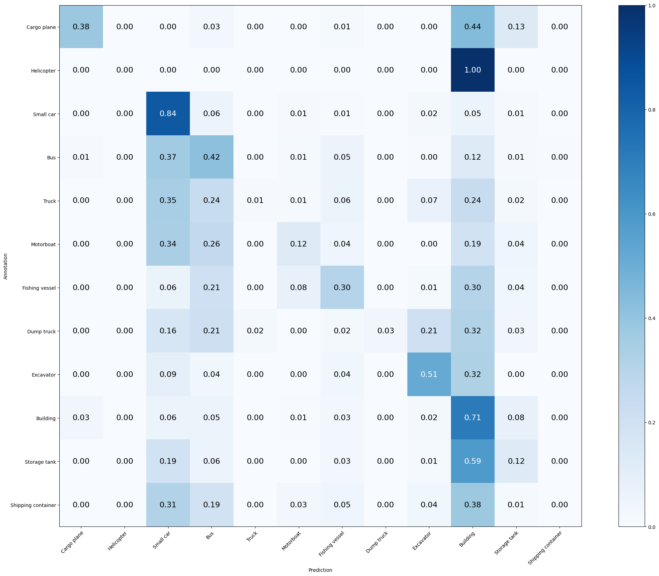

Mean Accuracy: 43.171%

Mean Recall: 28.794%

Mean Precision: 35.830%

> Cargo plane: Recall: 38.235% Precision: 57.778% Specificity: 99.082% Dice: 46.018%

> Helicopter: Recall: 0.000% Precision: 0.000% Specificity: 99.953% Dice: 0.000%

> Small car: Recall: 84.286% Precision: 51.009% Specificity: 80.210% Dice: 63.555%

> Bus: Recall: 41.553% Precision: 29.167% Specificity: 88.484% Dice: 34.275%

> Truck: Recall: 1.132% Precision: 50.000% Specificity: 99.840% Dice: 2.214%

> Motorboat: Recall: 12.360% Precision: 32.353% Specificity: 98.878% Dice: 17.886%

> Fishing vessel: Recall: 29.870% Precision: 25.556% Specificity: 96.749% Dice: 27.545%

> Dump truck: Recall: 3.419% Precision: 80.000% Specificity: 99.951% Dice: 6.557%

> Excavator: Recall: 51.282% Precision: 36.036% Specificity: 96.553% Dice: 42.328%

> Building: Recall: 70.968% Precision: 47.185% Specificity: 76.005% Dice: 56.683%

> Storage tank: Recall: 12.418% Precision: 20.879% Specificity: 96.373% Dice: 15.574%

> Shipping container: Recall: 0.000% Precision: 0.000% Specificity: 99.849% Dice: 0.000%

**MODEL 1**: Aumento batch size (16 to 32), reducción early stopping (40 to 5), reducción ReduceLROnPlateau (factor to 0.5 and patience to 3)

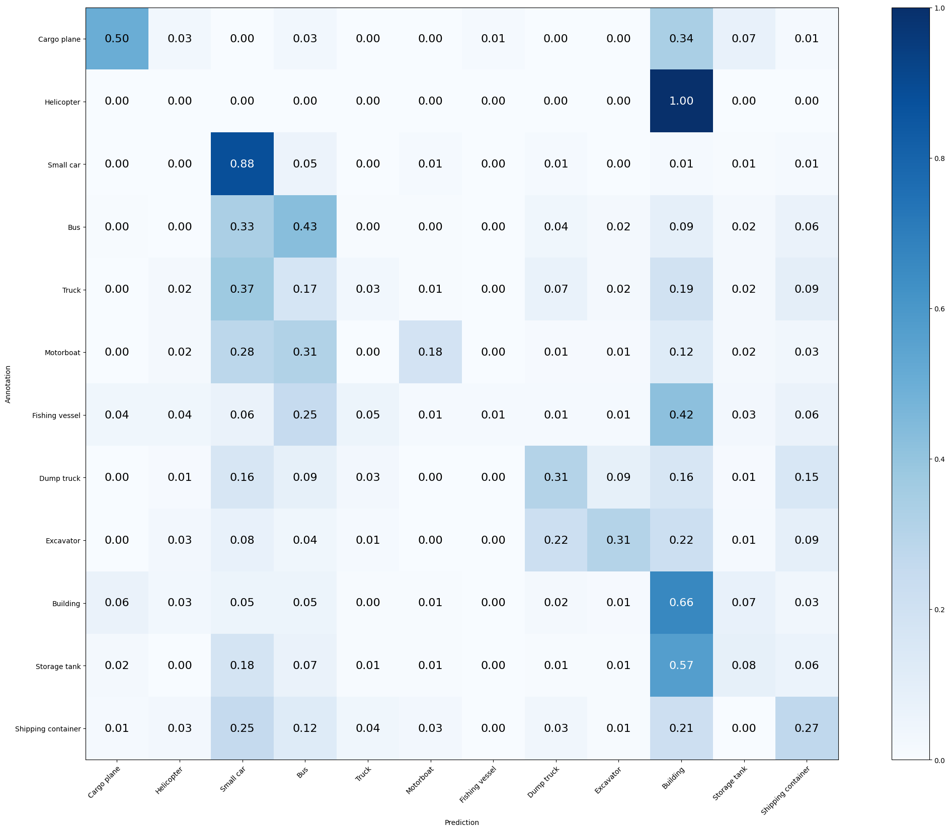

Mean Accuracy: 45.182%

Mean Recall: 30.525%

Mean Precision: 36.771%

> Cargo plane: Recall: 50.000% Precision: 45.333% Specificity: 98.019% Dice: 47.552%

> Helicopter: Recall: 0.000% Precision: 0.000% Specificity: 98.361% Dice: 0.000%

> Small car: Recall: 88.095% Precision: 53.701% Specificity: 81.432% Dice: 66.727%

> Bus: Recall: 42.922% Precision: 33.692% Specificity: 90.360% Dice: 37.751%

> Truck: Recall: 3.019% Precision: 30.769% Specificity: 99.039% Dice: 5.498%

> Motorboat: Recall: 17.978% Precision: 48.485% Specificity: 99.170% Dice: 26.230%

> Fishing vessel: Recall: 1.299% Precision: 50.000% Specificity: 99.951% Dice: 2.532%

> Dump truck: Recall: 30.769% Precision: 36.000% Specificity: 96.833% Dice: 33.180%

> Excavator: Recall: 30.769% Precision: 44.444% Specificity: 98.544% Dice: 36.364%

> Building: Recall: 66.331% Precision: 52.305% Specificity: 81.730% Dice: 58.489%

> Storage tank: Recall: 8.497% Precision: 18.056% Specificity: 97.028% Dice: 11.556%

> Shipping container: Recall: 26.623% Precision: 28.472% Specificity: 94.808% Dice: 27.517%

**MODEL 2**: Reducido beta 1 (0.9 to 0.8), epsilon (1e-7 to 1e-9), learning rate (o.001 to 0.00001)  
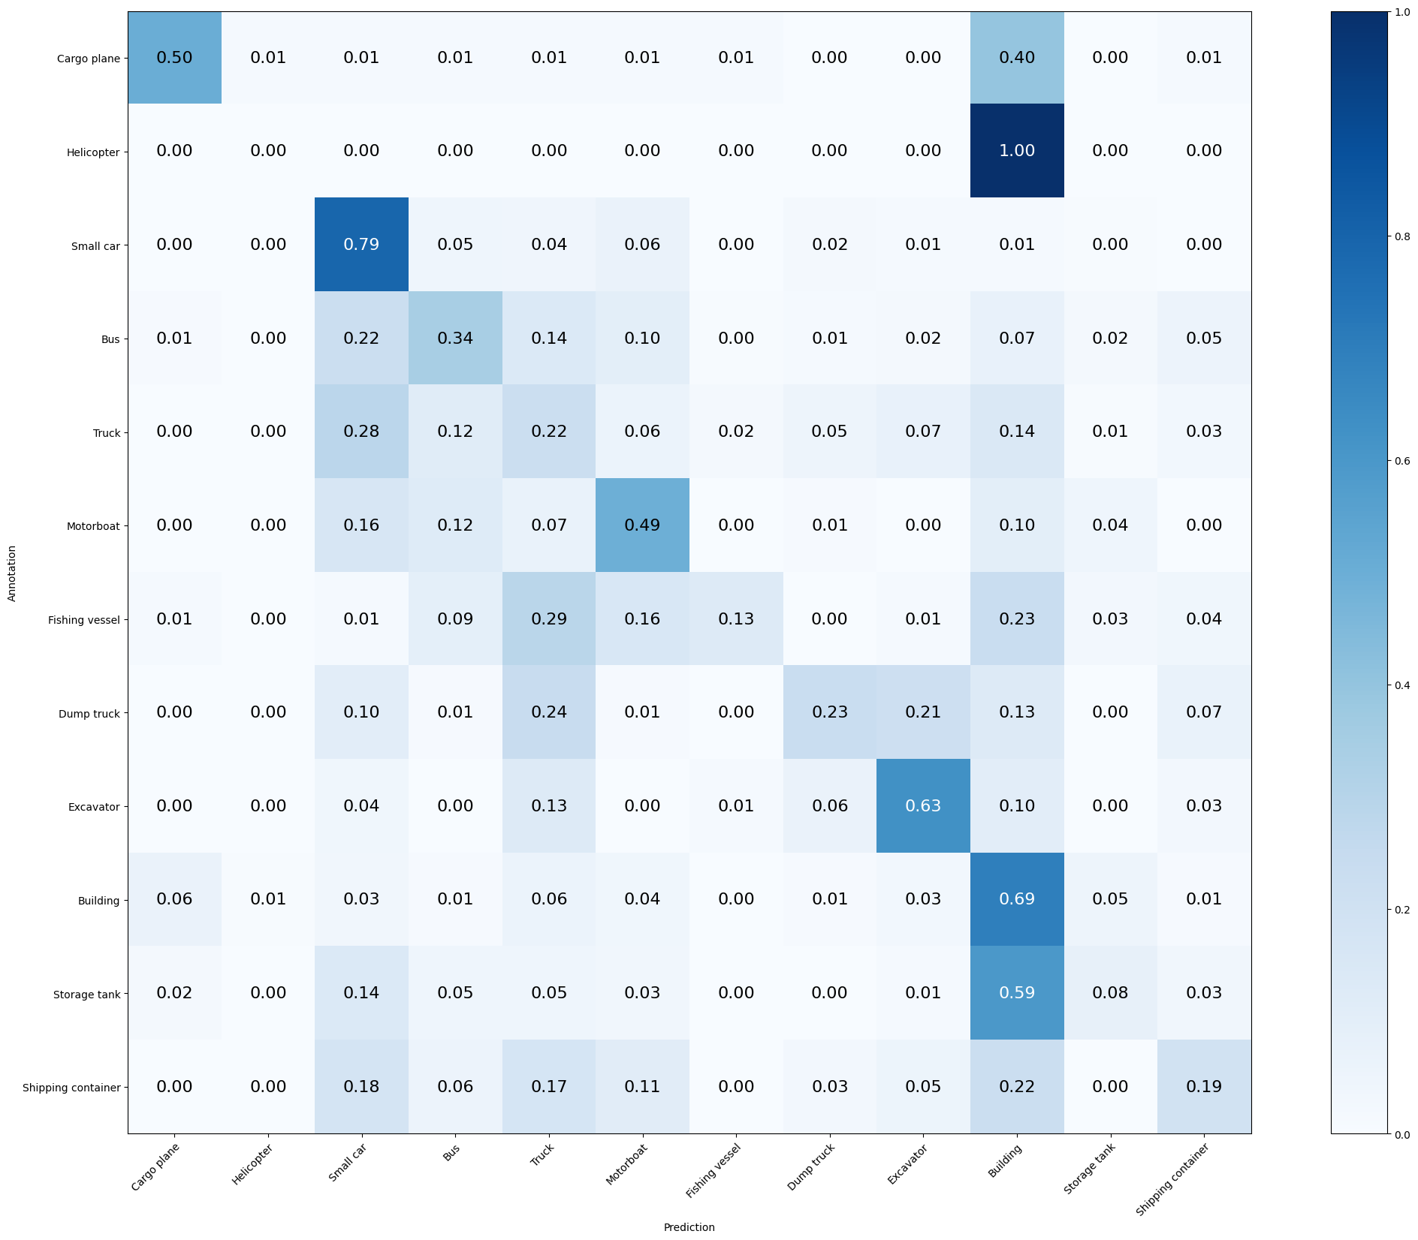

Mean Accuracy: 47.428%

Mean Recall: 35.797%

Mean Precision: 37.965%

> Cargo plane: Recall: 50.000% Precision: 47.222% Specificity: 98.164% Dice: 48.571%

> Helicopter: Recall: 0.000% Precision: 0.000% Specificity: 99.813% Dice: 0.000%

> Small car: Recall: 79.286% Precision: 60.217% Specificity: 87.194% Dice: 68.448%

> Bus: Recall: 34.247% Precision: 45.181% Specificity: 95.258% Dice: 38.961%

> Truck: Recall: 21.887% Precision: 24.681% Specificity: 90.550% Dice: 23.200%

> Motorboat: Recall: 49.438% Precision: 26.829% Specificity: 94.143% Dice: 34.783%

> Fishing vessel: Recall: 12.987% Precision: 52.632% Specificity: 99.563% Dice: 20.833%

> Dump truck: Recall: 23.077% Precision: 40.299% Specificity: 98.021% Dice: 29.348%

> Excavator: Recall: 62.821% Precision: 38.281% Specificity: 96.165% Dice: 47.573%

> Building: Recall: 69.153% Precision: 56.507% Specificity: 83.922% Dice: 62.194%

> Storage tank: Recall: 7.843% Precision: 24.000% Specificity: 98.086% Dice: 11.823%

> Shipping container: Recall: 18.831% Precision: 39.726% Specificity: 97.782% Dice: 25.551%

**MODEL 3:** Incrementado Batch size (32 to 64) y subido beta 2 (0.9 to 0.999) para mejorar momentum updates

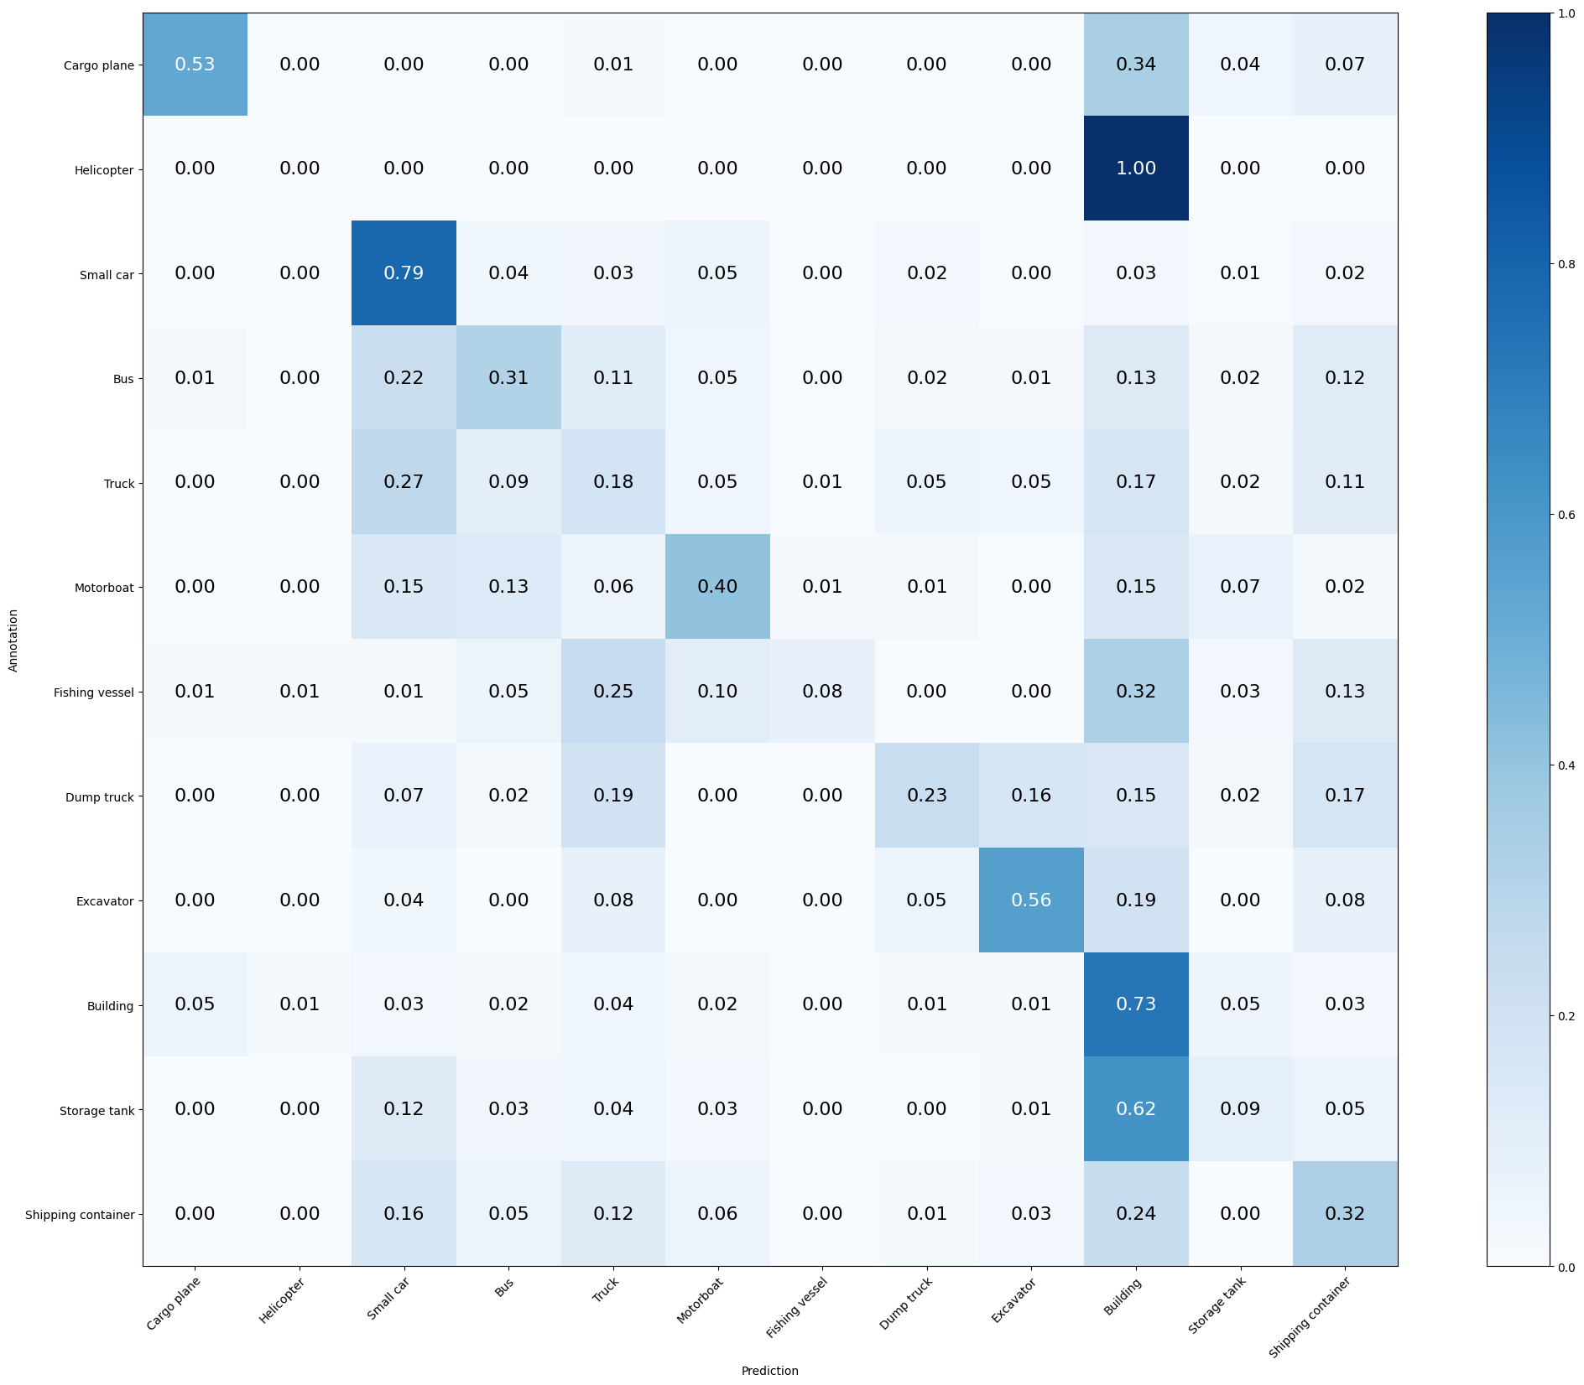

**Mean Accuracy: 47.895%**

**Mean Recall: 35.316%**

**Mean Precision: 39.007%**

**> Cargo plane: Recall: 52.941% Precision: 54.545% Specificity: 98.551% Dice: 53.731%**

**> Helicopter: Recall: 0.000% Precision: 0.000% Specificity: 99.719% Dice: 0.000%**

**> Small car: Recall: 78.571% Precision: 61.914% Specificity: 88.184% Dice: 69.255%**

**> Bus: Recall: 31.050% Precision: 45.946% Specificity: 95.831% Dice: 37.057%**

**> Truck: Recall: 18.491% Precision: 26.203% Specificity: 92.632% Dice: 21.681%**

**> Motorboat: Recall: 40.449% Precision: 33.028% Specificity: 96.437% Dice: 36.364%**

**> Fishing vessel: Recall: 7.792% Precision: 54.545% Specificity: 99.757% Dice: 13.636%**

**> Dump truck: Recall: 23.077% Precision: 39.706% Specificity: 97.971% Dice: 29.189%**

**> Excavator: Recall: 56.410% Precision: 48.352% Specificity: 97.718% Dice: 52.071%**

**> Building: Recall: 73.387% Precision: 53.846% Specificity: 80.999% Dice: 62.116%**

**> Storage tank: Recall: 9.150% Precision: 22.222% Specificity: 97.531% Dice: 12.963%**

**> Shipping container: Recall: 32.468% Precision: 27.778% Specificity: 93.448% Dice: 29.940%**

**MODEL 5:** Optimizer utilizando SGD (learning_rate=0.1, weight_decay=1e-6, momentum=0.9, nesterov=True), batch size 64 y loss=mean_squared_error

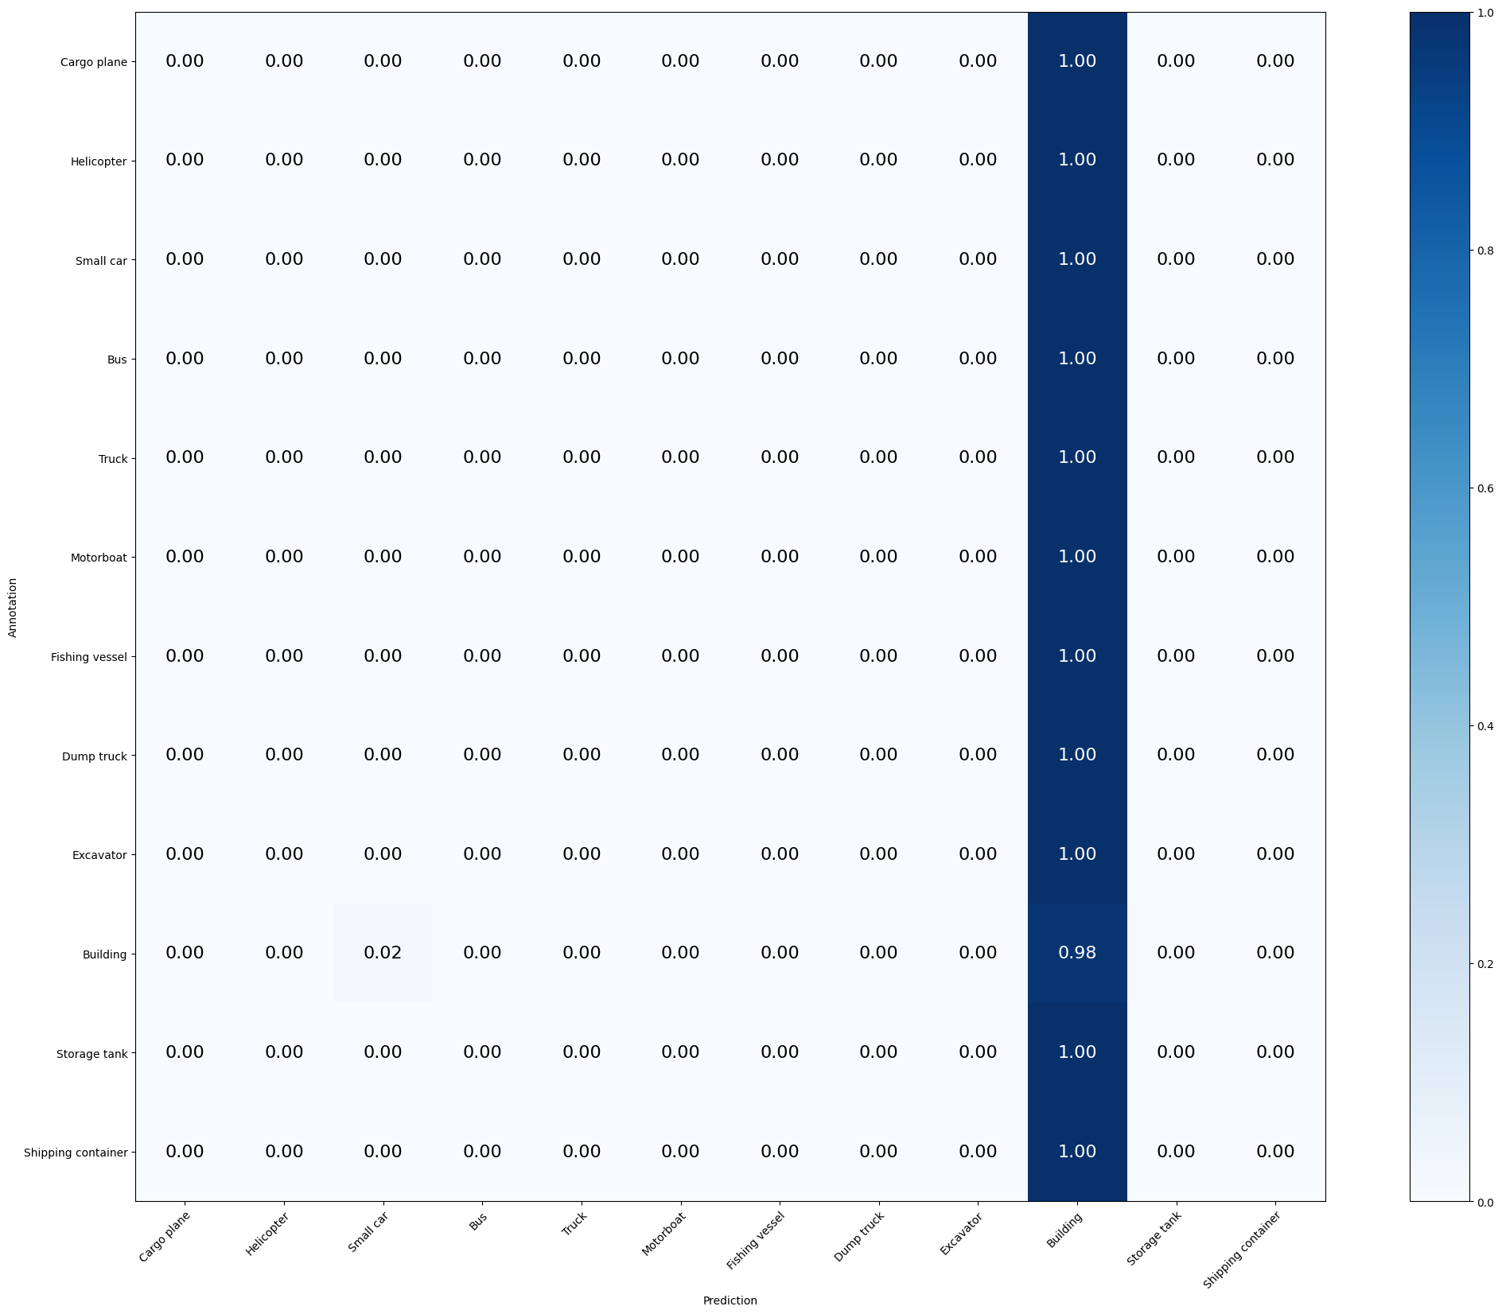

**MODEL 5:** Optimizer utilizando SGD (learning_rate=0.1, weight_decay=1e-6, momentum=0.9, nesterov=True), batch size 64 y loss=binary_crossentropy

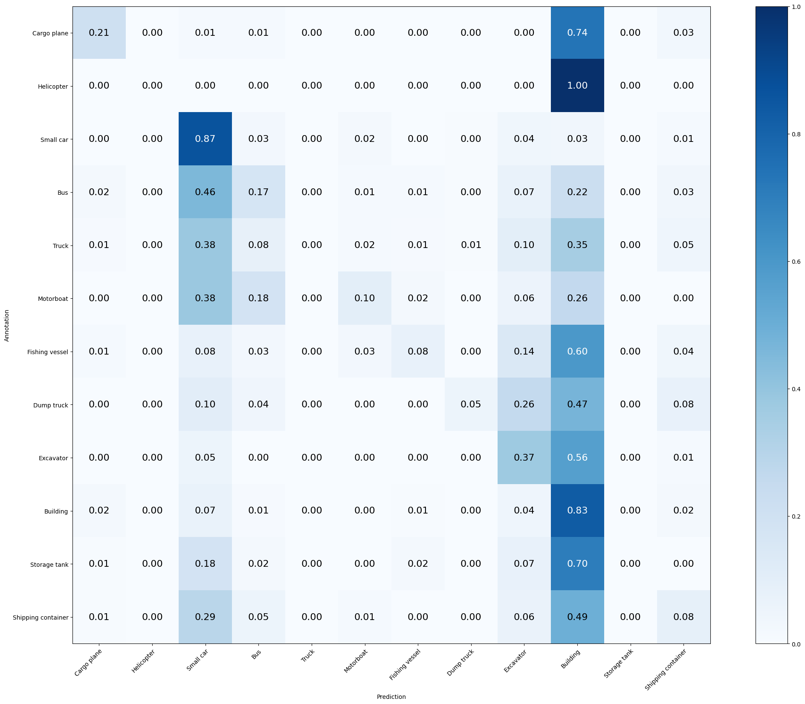

Mean Accuracy: 41.628%

Mean Recall: 22.989%

Mean Precision: 26.909%

> Cargo plane: Recall: 20.588% Precision: 43.750% Specificity: 99.130% Dice: 28.000%

> Helicopter: Recall: 0.000% Precision: 0.000% Specificity: 100.000% Dice: 0.000%

> Small car: Recall: 86.667% Precision: 50.000% Specificity: 78.813% Dice: 63.415%

> Bus: Recall: 16.895% Precision: 33.945% Specificity: 96.248% Dice: 22.561%

> Truck: Recall: 0.000% Precision: 0.000% Specificity: 100.000% Dice: 0.000%

> Motorboat: Recall: 10.112% Precision: 31.034% Specificity: 99.024% Dice: 15.254%

> Fishing vessel: Recall: 7.792% Precision: 30.000% Specificity: 99.321% Dice: 12.371%

> Dump truck: Recall: 5.128% Precision: 54.545% Specificity: 99.753% Dice: 9.375%

> Excavator: Recall: 37.179% Precision: 16.571% Specificity: 92.913% Dice: 22.925%

> Building: Recall: 83.065% Precision: 42.430% Specificity: 65.956% Dice: 56.169%

> Storage tank: Recall: 0.000% Precision: 0.000% Specificity: 100.000% Dice: 0.000%

> Shipping container: Recall: 8.442% Precision: 20.635% Specificity: 97.480% Dice: 11.982%